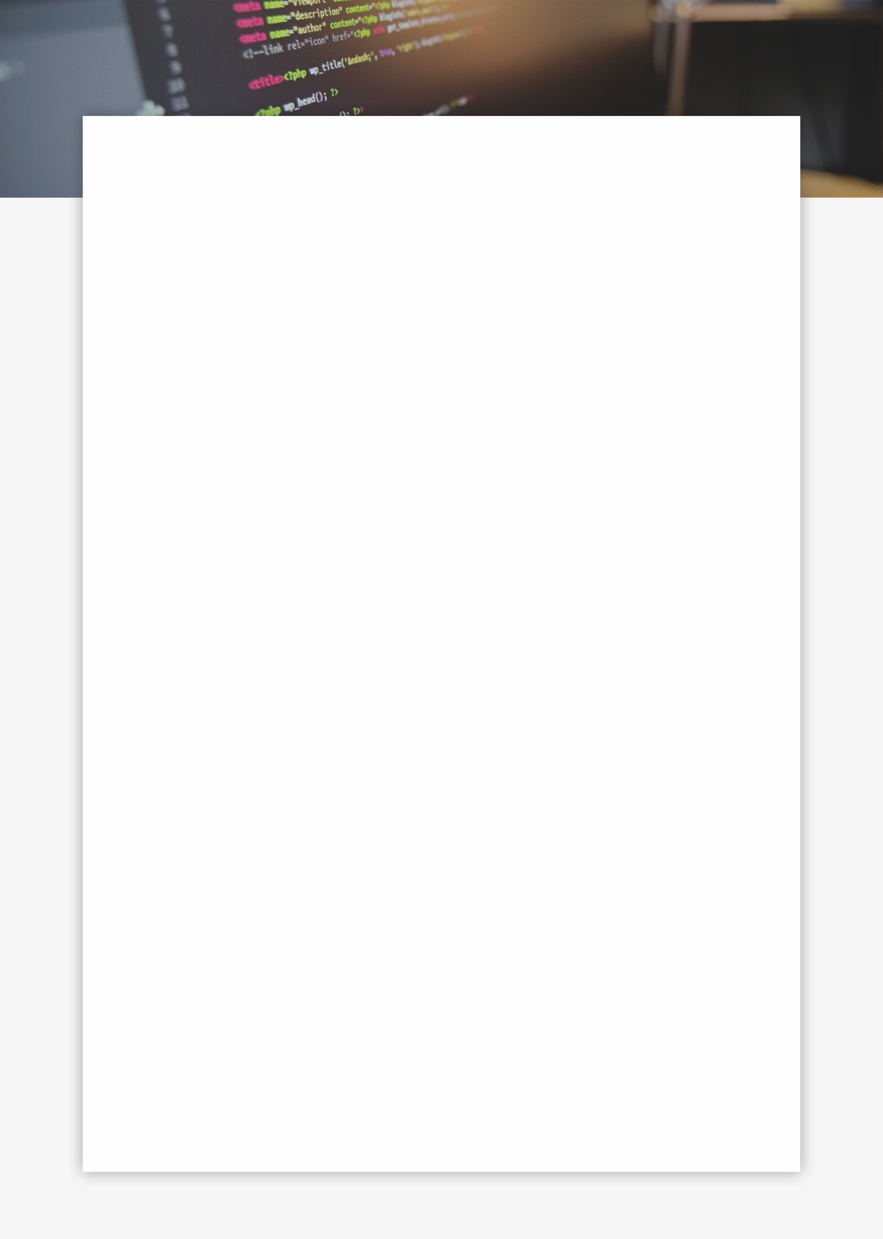

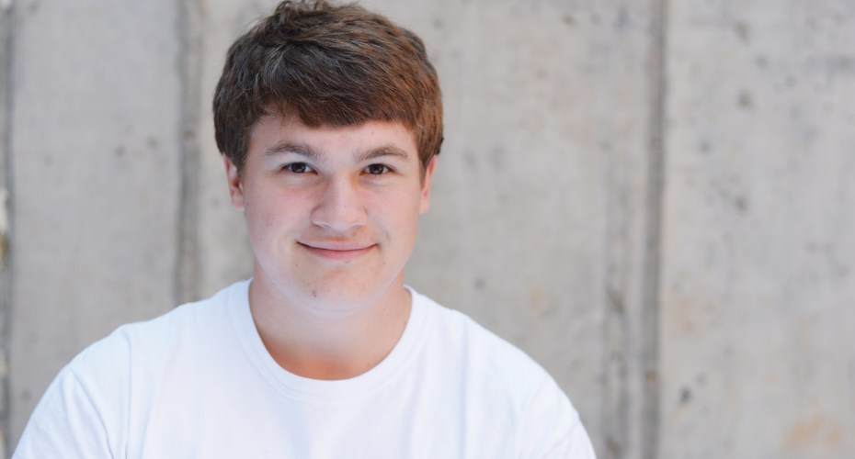

 Education

**Kansas State University** **/ Bachelors in Computer Engineering**August 2017 / May 2021  
Member of the Powercat Motorsports Formula SAE team, Electrical Systems Team; Hack K-State Club; Game Development Club; KSU IEEE Club, and KSU IMBS.

**Shawnee Mission East** **/ High school Diploma**August 2013 / May 2017  
Lorem ipsum dolor sit amet, consectetur adipiscing elit, sed do eiusmod tempor incididunt ut labore et dolore magna aliqua. Ut enim ad minim veniam, quis nostrud exercitation ullamco laboris nisi ut aliquip ex ea commodo consequat.

 Work Experience

**Collegian Media Group** **/ Web Developer | Head of Technology**October 2017 / Present  
Web Developer for the student publications department at Kansas State University. Created and developed websites for each of the publications, and multiple colleges and companies around campus.

**HitchPin LLC.** **/ Software Engineer | Head of UI/UX design**January 2018 / Present  
Worked on developing and creating an app for a Manhattan based start-up. Lead multiple projects on creating and developing a responsive and fresh UI design that would simple for the user. Also lead the creation of secure mobile payments.

**Freelance Web Developer** October 2016 / Present  
Worked as freelance Web Developer to help my parents make ends meet. Created and redesigned multiple websites for teachers, friends, and colleagues throughout high school.

**IEEE/ Web Developer | KSU Student Chapter**January 2018 / Present  
Created and developing a website for the Kansas State University chapter of the International order of Electrical and Electronics Engineer Society. The website is used as a focal point to draw in new members into the society.

 Get in Touch

  
 **+ 1** (913) **486 9114**

  
**amasson99**@gmail.com

  
  
https://amasson99.github.io

github.com/amasson99

linkedin.com/alex-massonb21574141

 Skills

Html  
  
CSS  
  
JavaScript  
  
Java  
  
C

Command Line

Security

 Profile

My name is Alex Masson, and I am a professional Web Developer and Software Engineer. I am also a student at Kansas State University pursuing a degree in Computer Engineering.

**ALEX MASSON**Web Developer / Software Engineer